SMART DUSTBIN

**A Project Report**

**Submitted by**

**Ambrish Kumar S – 20201CEI0001 K V Sumanth - 20201CEI0005 Bharath V -20201CEI0021 Rihan Anwar – 20201CEI0030 Soumil Chowdhury – 20201CEI0040**

**Under the guidance of**

**Dr.A Maheshwari Senthi Kumar**



# Department of Computer Science and Engineering School of Engineering

**PRESIDENCY UNIVERSITY**

# March 2023

**TABLE OF CONTENTS**

1. **ACKNOWLEDGEMENT**
2. **ABSTRACT**
3. **INTRODUCTION**
4. **COMPONENTS**
5. **METHODOLOGY**
6. **WORKING PRINCIPLE**
7. **ADVANTAGES**
8. **SKETCH**
9. **IMAGES OF THE OUTPUT**
10. **CONCLUSION**
11. **REFERENCES**
12. **COST OF COMPONENTS**

**ACKNOWLEDGEMENT**

We are thankful to the institute, Presidency University, thus allowing us to do a professional and technical mini project.

We would like to express our gratitude to **Dr.Maheshwari Senthi Kumar** Mentor for her precious reviews in bringing this project to life. We take this opportunity to thank him for his inspirational guidance, valuable suggestions and providing me a chance for the completion of the Mini Project.

We are proud of the strong support and inspiration our team has provided

altogether in bringing out this project.

**ABSTRACT**

The main objective of the project is to design a smart dustbin which will help in keeping our environment clean and also eco-friendly. Nowadays technologies are getting smarter day-by-day so, as to clean the environment we are designing a smart dustbin by using Arduino. This smart dustbin system is built on the microcontroller based system having ultrasonic sensors on the dustbin. If dustbin is not maintained than these can cause an unhealthy environment and can cause pollute that affect our health. In this proposed technology we have designed a smart dustbin using ARDUINO UNO, along with ultrasonic sensor, servo motor, and battery jumper wire. After all hardware and software connection, now Smart Dustbin program will be run. Dustbin lid will open when someone comes near at some range than wait for user to put garbage and close it. For social it will help toward health and hygiene, for business we try to make it affordable to many as many possible. So that normal people to rich people can take benefit from it.

**INTRODUCTION**

Aim: To develop an IOT based Smart Dustbin using Arduino Uno

* Though the world is in a stage of up gradation, there is yet another problem that must be dealt with. -Garbage! Pictures of garbage bins being overfull, and the garbage being spilled out from the bins can be seen all around.

* This leads to various diseases as large number of insects and mosquitoes breed on it.

* A big challenge in the urban cities is solid waste management. -Hence, smart dustbin is a system which can eradicate this problem or at least reduce it to the minimum level.

* Our present Prime Minister of India, Sri Narendra Modi ji has introduced the concept of implementing 100 smart cities in India. “Swachh Bharat Abhiyaan” was initiated to ensure a clean environment.

* Majority of viruses and bacterial infections develop in polluted environment.

* Safeguarding the environment using technology sources is needed at present.

* Majority of the public environment seems to be polluted with the waste material. So, modernization of the restaurants is needed by imparting the smart technology. Amounts of waste are largely determined by two factors: first, the population in any given area, and second, its consumption patterns.

**COMPONENTS**

* ESP 32 Module
* Ultrasonic Sensor
* Servo Motor
* 9V Battery
* Jumper Wires

# Esp 32 Module

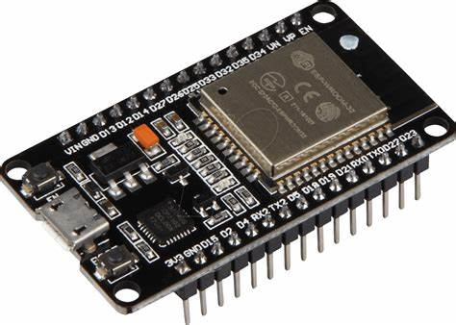

**ESP32** is a series of low-cost, low-power [system on a chip](https://en.wikipedia.org/wiki/System_on_a_chip) [microcontrollers](https://en.wikipedia.org/wiki/Microcontroller) with integrated [Wi-Fi](https://en.wikipedia.org/wiki/Wi-Fi) and dual-mode [Bluetooth](https://en.wikipedia.org/wiki/Bluetooth). The ESP32 series employs either a [Tensilica](https://en.wikipedia.org/wiki/Tensilica" \o "Tensilica) Xtensa LX6 microprocessor in both dual-core and [single-core](https://en.wikipedia.org/wiki/Single-core) variations, Xtensa LX7 dual-core microprocessor or a [single-core](https://en.wikipedia.org/wiki/Single-core) [RISC-V](https://en.wikipedia.org/wiki/RISC-V) microprocessor and includes built-in antenna switches, [RF](https://en.wikipedia.org/wiki/Radio_frequency) [balun](https://en.wikipedia.org/wiki/Balun), power amplifier, low-noise receive amplifier, filters, and power-management modules.

# Ultrasonic Sensor

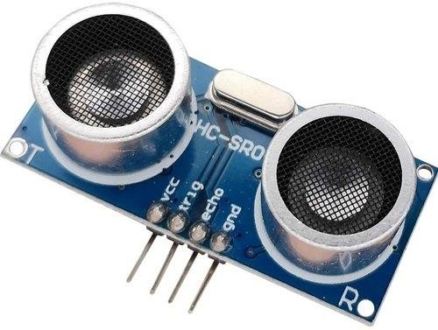

It is an electronic device that measures the distance of a target object by emitting ultrasonic sound waves and converts the reflected sound into an electrical signal.

# Servo Motor

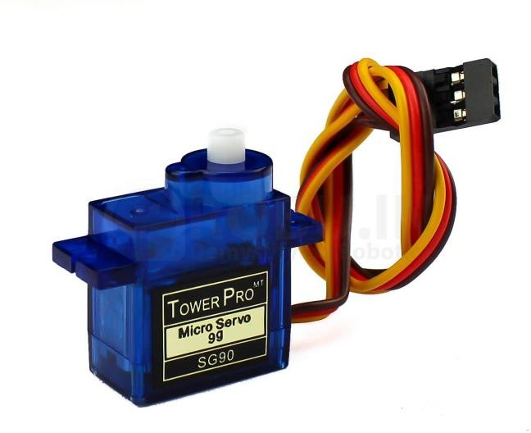

It rotates with great precision. It controls the opening and closing of the bin.

# Jumper Wires

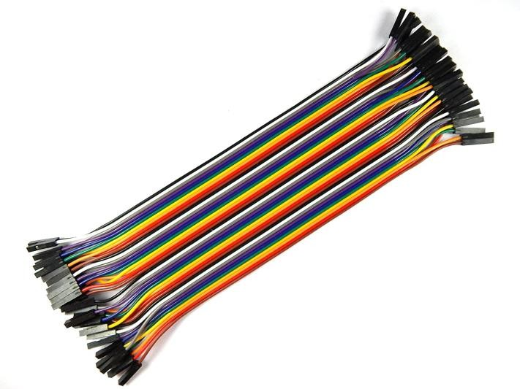

It is an electrical wire with a connector at end. They are used to connect two points male and female in a circuit.

**Methodology**

The methodology of a smart dustbin involves integrating various sensors and technologies to make the dustbin more efficient and effective. Here are some key components and features of a smart dustbin:

Sensor-based opening: The dustbin can be equipped with sensors that detect when someone approaches it and automatically open the lid, making it more convenient for users to dispose of their waste.

Capacity sensors: Capacity sensors can be added to the dustbin to detect when it's full and notify the cleaning staff to empty it. This ensures that the dustbin doesn't overflow and cause littering.

Compactor: A compactor can be added to the dustbin, which compresses the waste as it is added, allowing more waste to be collected in the same amount of space.

Segregation: The smart dustbin can have separate compartments for different types of waste such as plastic, paper, and food waste. This helps in proper waste segregation and disposal.

Monitoring: The dustbin can be equipped with IoT technology that can monitor the status of the dustbin in real-time, such as the amount of waste collected, the location of the dustbin, and the status of the sensors.

Alert system: An alert system can be integrated into the dustbin that can send notifications to the cleaning staff when the dustbin is full or needs to be emptied.

Power source: The smart dustbin can be powered by a rechargeable battery or by solar power, making it eco-friendly and reducing its carbon footprint.

Overall, a smart dustbin can help in improving waste management and reducing littering. By integrating the above features, the dustbin becomes more efficient, hygienic, and convenient for the users.

**WORKING PRINCIPLE**

After wiring and attaching all the devices and setting up to the Smart Dustbin, now observe all the important setup whether they are well connected or something missed. After connecting the set-up, now next step is to submit/upload code in Arduino and supply power to the circuit. When system is powered ON, Arduino keeps monitoring for any things that come near the sensor at given range. When Ultrasonic sensor detect any object for example like hand or others, here Arduino calculates its distance and if it less than a certain predefines value than servo motor get activate first and with the support of the extended arm of the lid. Lid will open for a given time than it will automatically close.

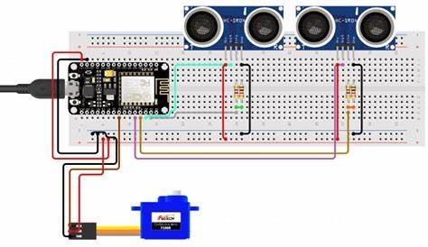

**ADVANTAGES**

n in the number of waste collections needed by up to 80%, resulting in less manpower, emissions, fuel use and traffic congestion.

Reduction in the number of waste bins needed. Maintain environment hygiene

It will help in bringing evolution by technology in term of cleanliness

**SKETCH / CODE**

#define BLYNK_TEMPLATE_ID "TMPL3ttdSMoWb"

#define BLYNK_TEMPLATE_NAME "smart dustbin"

#define BLYNK_AUTH_TOKEN "H2Gk0kEgu2Z-XRGVDFrUuhXJZG5VrA4o"

#include <Adafruit_Sensor.h>

#include <ESP32Servo.h>

#include <WiFi.h>

#include <WiFiClient.h>

#include <BlynkSimpleEsp32.h>

#define BLYNK_PRINT Serial

char auth[] = BLYNK_AUTH_TOKEN;

// Your WiFi credentials.

// Set password to "" for open networks.

char ssid[] = "rpi";

char pass[] = "12345678";

BlynkTimer timer;

#include <LiquidCrystal_I2C.h>

LiquidCrystal_I2C lcd(0x27, 16, 2);

//sda D2, sdl D1

Servo myservo;

Servo myservo1;

int mdelay=3000;

#define echoPin1 18

#define trigPin1 19

#define echoPin2 13

#define trigPin2 12

#define buzzer 15

long duration;

int distance;

int obstacle(int trigPinx, int echoPinx) {

digitalWrite(trigPinx, LOW);

delayMicroseconds(2);

digitalWrite(trigPinx, HIGH);

delayMicroseconds(10);

digitalWrite(trigPinx, LOW);

duration = pulseIn(echoPinx, HIGH);

distance = duration * 0.034 / 2;

return distance;

}

void frontdetection()

{

int dist2 = obstacle(trigPin2,echoPin2);

Serial.println(dist2);

if (dist2 < 10){

myservo1.write(90);

delay( mdelay);

}

else{

myservo1.write(180);

delay( mdelay);

}

}

void leveldetection()

{

int dist1 = obstacle(trigPin1,echoPin1);

// Serial.println(dist1);

Blynk.virtualWrite(V2,dist1);

if (dist1 < 10){

Blynk.virtualWrite(V1,"Dustbin is overfull");

Serial.println(dist1);

lcd.setCursor(8, 1);

lcd.print("D- FULL");

}

else{

// Blynk.notify("Dustbin is supposed to be overfull");

lcd.setCursor(8, 1);

lcd.print("D- EMPTY");

Blynk.virtualWrite(V1,"Dustbin is normal");

}

}

void setup()

{

Serial.begin(115200);

Blynk.begin(auth, ssid, pass, "blynk.cloud", 80);

lcd.init();

lcd.backlight();

myservo.attach(5);

// myservo.write(90);

myservo1.attach(23);

myservo1.write(90);

pinMode(buzzer, OUTPUT);

pinMode(trigPin1, OUTPUT);

pinMode(echoPin1, INPUT);

pinMode(trigPin2, OUTPUT);

pinMode(echoPin2, INPUT);

timer.setInterval(1000L, leveldetection);

timer.setInterval(2000L, frontdetection);

}

void loop()

{

Blynk.run();

timer.run();

}

**IMAGES OF THE OUTPUT**

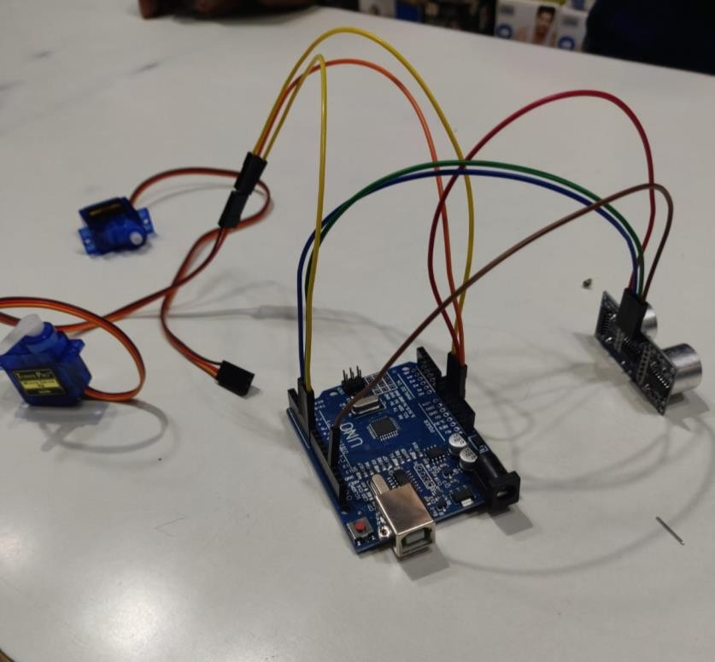

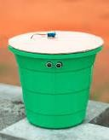

**CONCLUSION**

Smart dustbins are better and shoulders above traditional garbage dustbin. It is equipped with smart devices like sensor Arduino etc. Lid of the dustbin will automatically open when an object comes near to the dustbin and after certain time period it will close the lid. For social it will help toward health and hygiene, for business we’ll try to make it affordable as far as possible. So that normal people to rich people can take benefit from it. Believe this will bring something changes in term of cleanliness as well technology.

# REFERENCES

**Websites:**

1. [https://www.researchgate.net/publication/325116872_Smart_dustbin_based_on](https://www.researchgate.net/publication/325116872_Smart_dustbin_based_on_IOT)

[_IOT](https://www.researchgate.net/publication/325116872_Smart_dustbin_based_on_IOT)

1. [https://www.researchgate.net/publication/343530056_SMART_DUSTBIN_USI](https://www.researchgate.net/publication/343530056_SMART_DUSTBIN_USING_ARDUINO) [NG_ARDUINO](https://www.researchgate.net/publication/343530056_SMART_DUSTBIN_USING_ARDUINO)
2. [www.Elecfreaks.com](http://www.elecfreaks.com/)
3. [www.alselectro.com](http://www.alselectro.com/)
4. <https://thingspeak.com/>
5. www.arduino-mightly/reference[/w](http://www.arduino.cc/)w[w.arduino.cc](http://www.arduino.cc/)

# COST OF COMPONENTS

|  |  |  |
| --- | --- | --- |
| **Components Name** | **Quantity** | **Cost** |
| Arduino Uno | 1 | 400 |
| Ultrasonic Sensor | 1 | 250 |
| Jumper Wire | 2 | 200 |
| Servo Motor | 1 | 110 |
| USB cable | 1 | 50 |
| Battery | 1 | 40 |
| Dustbin | 1 | 50 |